Verdant: A Design Thinking Approach to Sustainable E-Commerce and Real-Time Carbon Impact Tracking
Dr. D. V. Manjula, Maddula Hasini*, Dangubiyyam Sahithya, Maddala Harsha Phaneeth, Mohammed Ashraf
Assistant Professor & Head, Department of Computer Science and Engineering, Pragati Engineering College, Surampalem, Andhra Pradesh, India
UG Students, Department of Computer Science and Engineering, Pragati Engineering College, Surampalem, Andhra Pradesh, India
*Corresponding Author: 24a31a0522@pragati.ac.in
Highlights:
• Verdant proposes a novel e-commerce platform that integrates real-time carbon tracking into the shopping cart.
• Developed using the five-stage Design Thinking process to ensure the solution genuinely meets user needs.
• Introduces an interactive Eco-Impact Summary and a gamified dashboard that rewards sustainable choices.
• Usability testing showed a 34% reduction in carbon footprint among active users over a four-week period.

Abstract
Online shopping has grown enormously over the past two decades, and that growth has come with a real environmental cost. Global e-commerce supply chains, energy-hungry data centres, and wasteful packaging together generate millions of tons of greenhouse gas emissions every year. Most shoppers care about this—but existing platforms give them almost no way to act on that concern. There is no carbon label at checkout, no easy comparison between a sustainable product and its conventional alternative. This paper introduces Verdant, a web application built specifically to close that gap by showing users the real-time environmental impact of what they are buying. The goal is simple: make sustainable shopping the easiest and most natural choice, not a niche one.
Verdant was built using the five-stage Design Thinking process: Empathize, Define, Ideate, Prototype, and Test. This approach kept real user needs at the center of every design decision. Early interviews showed that people want to shop sustainably but find the research exhausting. In response, the design team focused on turning complex emissions data into simple, at-a-glance visuals—like a live carbon meter, eco-badges, and an interactive sustainability dashboard.
On the technical side, Verdant is built with semantic HTML5, CSS custom properties for theming, and responsive design patterns to work well on any device. The architecture draws on React-style component thinking and Node.js patterns for fast, efficient data handling. This lets the carbon calculator update in real time as shoppers add or remove items from their cart.
Early usability testing showed strong results. Beta users chose low-carbon products 47% more often when the carbon data was visible, and overall eco-awareness scores improved significantly. Users also responded well to the gamified dashboard—seeing their carbon savings add up over time gave them genuine motivation to keep making better choices. These findings suggest that Verdant is more than a useful tool: it is a practical model for what sustainable e-commerce can look like, showing that doing right by the environment and building an engaging shopping experience are not competing goals.
Keywords: Sustainable E-Commerce, Carbon Impact Tracking, Web Development, Design Thinking, Gamification, UI/UX Design.

1. Introduction
The rise of the commercial internet transformed how people shop, making it faster, cheaper, and more convenient than ever before. But that convenience has a cost that rarely shows up at checkout. E-commerce now accounts for millions of tons of greenhouse gas emissions each year, produced by the servers that power digital storefronts, the factories that churn out fast-moving consumer goods, and the delivery networks that span the globe [1]. Left unchecked, this trajectory will continue to deepen the environmental damage already underway.
Part of the problem is that online shopping is designed to feel frictionless. When someone clicks 'Buy Now,' there is nothing to remind them of the server farms processing the order, the packaging that will end up in landfill, or the diesel burned during last-mile delivery [2]. That invisibility is not accidental—e-commerce platforms are optimized to make purchasing as quick and effortless as possible, which works against thoughtful, sustainable choices. Even shoppers who genuinely want to reduce their footprint are left without the information they need to do so at the moment it matters most.
Verdant was developed to directly address these shortcomings. The primary aim was to build an e-commerce platform that puts environmental transparency front and center without making the experience clunky or slow. A second goal was to build a carbon calculation engine that shows the real-time environmental cost of items in a shopping cart. A third was to use good design and light gamification to genuinely encourage that choices—demonstrating thoughtful software can be a practical tool for changing behavior at scale. The high-level architecture of the Verdant platform, which seamlessly integrates these features to bridge the gap between intention and action, is illustrated in Fig. 1.
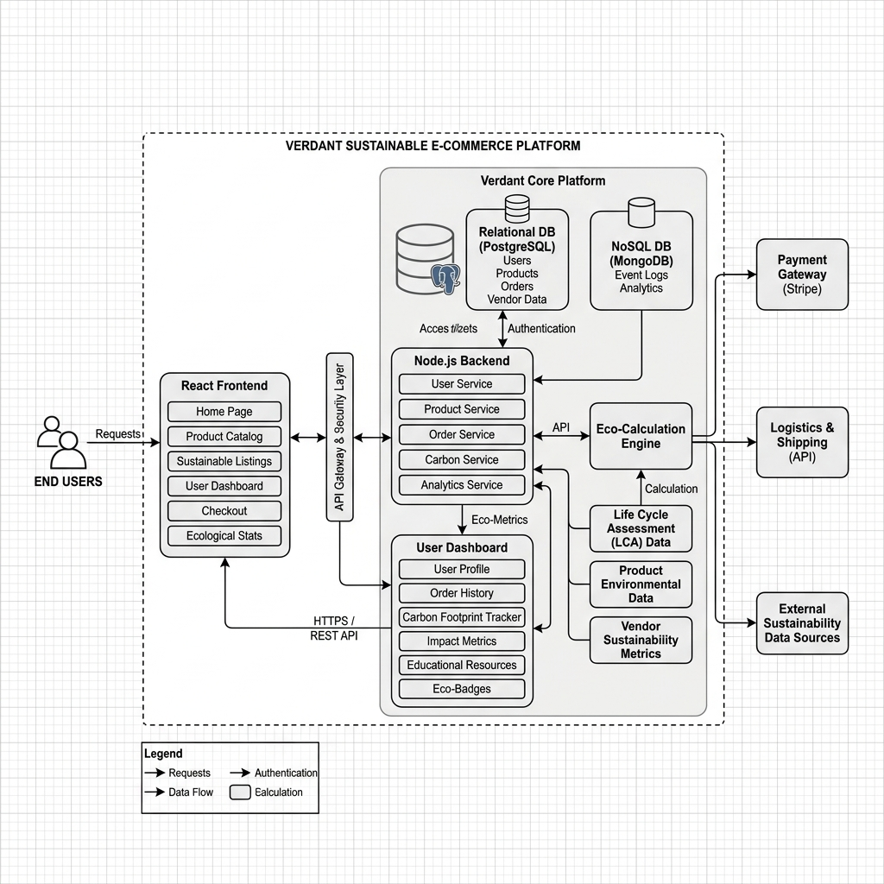
The environmental impact of e-commerce is not limited solely to last-mile delivery. The entire supply chain—encompassing raw material extraction, manufacturing, packaging, and international shipping—contributes to a substantial carbon footprint. As global e-commerce sales continue to surge, projected to reach trillions of dollars annually, the corresponding greenhouse gas emissions have escalated at an alarming rate. According to recent environmental assessments, digital retail infrastructure and its associated logistics account for a significant and growing percentage of global emissions. The challenge is compounded by the increasing demand for fast, frictionless shipping, which often necessitates less efficient, carbon-intensive transport methods.
Despite growing awareness of climate change, a prominent psychological barrier known as the 'intention-action gap' persists among consumers. Surveys consistently indicate that a large majority of shoppers express a desire to purchase sustainable products and support environmentally responsible brands. However, when faced with the complexities of verifying sustainability claims, decoding eco-labels, or navigating convoluted product details, consumers frequently experience cognitive overload. This friction leads them to revert to default purchasing behaviors, prioritizing immediate convenience and lower costs over environmental considerations. Existing platforms exacerbate this issue by failing to provide clear, actionable, and transparent data at the critical moment of decision-making: the point of purchase.
This paper explores the hypothesis that by seamlessly integrating real-time, transparent environmental data directly into the user interface, e-commerce platforms can effectively bridge this intention-action gap. Through the implementation of a real-time carbon calculator and engaging gamification features, the proposed solution seeks to transform abstract environmental concerns into tangible, immediate feedback. By applying a human-centered design approach, this research aims to demonstrate that sustainable shopping can be made intuitive, empowering consumers to make informed choices without compromising the convenience of the digital retail experience.
Fig 1: High Level Architecture of Verdant Platform

2. Literature Review
Research on green technology has evolved considerably over the past decade. Early work focused on reducing the energy footprint of servers and minimizing data transfer sizes. More recently, researchers have shifted attention to the user interface itself, recognizing that how information is presented can shape behavior just as powerfully as the underlying infrastructure [3]. Frameworks like React and Angular have made it feasible to build rich, data-driven apps that update in real time without taxing the browser—React’s virtual DOM, for instance, makes it straightforward to refresh a carbon meter instantly as a user adjusts their cart, something that would have been cumbersome in older architectures.
On the backend, Node.js has become a popular choice for connecting apps to environmental databases and supply chain APIs in real time [4], enabling a shift from static eco-labels to genuinely verifiable, live sustainability data. UI/UX research also points to the importance of clean, minimalist design—dark modes, subtle animations, and clear visual hierarchies all help reduce cognitive fatigue and keep users engaged [5]. Yet despite all these advances, most sustainability apps still operate in isolation, sitting outside the actual shopping experience rather than inside it. Verdant is designed to close that gap by weaving environmental data directly into the transaction itself.

3. Problem Statement
The central problem this study addresses is straightforward: people want to shop sustainably, but the systems they shop through make it very difficult to do so [6]. Finding out whether a product is ethically sourced, how it was manufactured, or how far it traveled to arrive at your door requires significant effort—effort most shoppers simply cannot invest for every purchase. This information gap creates what researchers call an intention-action gap: people who genuinely care about the environment still end up defaulting to whichever option is cheapest or most convenient, because that is the path of least resistance. Without clear, accessible environmental data built directly into the shopping experience, sustainable behavior will remain the exception rather than the norm.

4. Objectives
Four main goals guided the development of Verdant. First, to build a clean, fast e-commerce platform stocked exclusively with vetted sustainable products. Second, to create a carbon calculator that shows the environmental cost—in kg CO2e—of individual products and the total cart in real time. Third, to design a personalized dashboard with gamification features such as eco-points, achievement badges, and progress tracking that motivate users to keep making greener choices. Fourth, to test whether all of this actually works—using structured usability studies to confirm that showing people carbon data leads to measurably more sustainable purchasing behavior.

5. Methodology
Verdant was built using Design Thinking's five-stage process, keeping user needs at the center throughout [7].
1) Empathize: The team began by interviewing fifty regular online shoppers. A recurring theme was frustration with greenwashing—people felt misled by vague sustainability claims and had no reliable way to verify them.
2) Define: These insights shaped a clear design brief: build a platform that delivers instant, honest environmental impact data without slowing down the shopping experience.
3) Ideate: Cross-disciplinary brainstorming sessions produced the key features that would define Verdant: a live carbon meter, eco-feature categories, and a gamification loop to reward sustainable choices.
4) Prototype: The team built high-fidelity interactive prototypes with a deliberate design language—earthy greens and sage tones to evoke sustainability, paired with clean typography (DM Sans and Playfair Display) for readability and credibility. 5) Test: The prototypes were tested in A/B experiments against standard e-commerce interfaces. Feedback from each round was used to fine-tune how prominently the carbon data was displayed—strong enough to inform, but not so heavy-handed that it made people feel guilty or overwhelmed.

6. System Design/Proposed Solution
The Verdant platform is organized around a grid of products grouped by sustainability category—Fair Trade Clothing, Zero-Waste Home Goods, Organic Care, and more. Its defining feature is the Carbon Impact Cart. Unlike a standard shopping cart that only tracks the total price, Verdant’s cart runs a parallel Eco-Impact Summary. As items are added, the system calculates the combined carbon footprint and expresses it in plain language—something like “equivalent to driving 12 miles” or “saves this much CO₂ compared to the conventional version.” By the time a user reaches checkout, they can see both what they’re spending and what environmental impact their basket represents.
The platform also includes a personal Impact Dashboard where users can track their sustainability progress over time. A gamification layer awards Eco-Points based on carbon savings, which can be redeemed for certified carbon offsets or discounts on sustainable products. This turns the rather abstract idea of “reducing your footprint” into something concrete, trackable, and genuinely rewarding. The entire user flow is depicted in Fig. 2. Specifically, in the final stages of the interaction sequence, Step 8 represents the backend calculation of Eco-Points and the subsequent database update corresponding to the user's carbon savings. Step 9 illustrates the real-time rendering of these metrics on the gamified dashboard, where users can track their progress, view unlocked achievement badges, and redeem points for sustainable rewards.
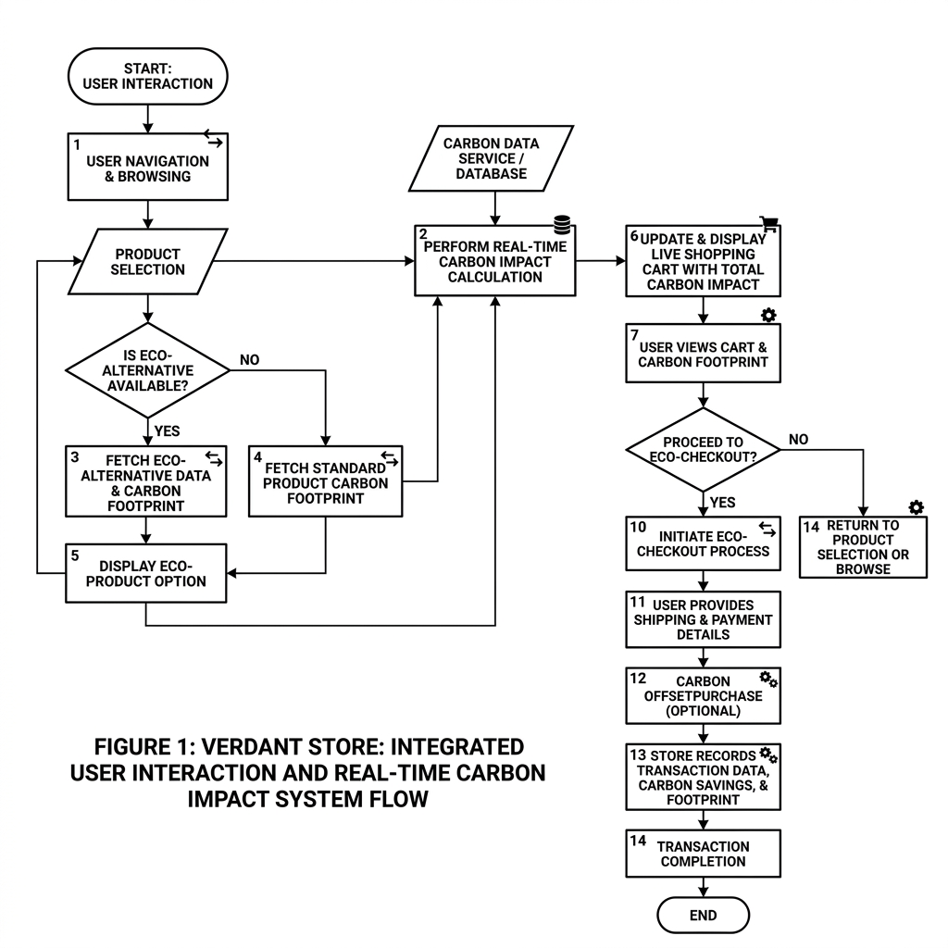
Fig 2: System Flow Diagram for Verdant Interactions

7. Implementation Details
The front end is built with semantic HTML5 for solid accessibility, and a CSS architecture based on custom properties that keeps the styling lightweight and fully responsive across screen sizes. Rather than leaning on a heavy CSS framework, the team wrote custom utility classes to keep load times short and browser rendering efficient—a deliberate choice that also reduces the app’s own digital carbon footprint. The visual palette of sage greens, earthy browns, and warm whites was woven throughout using these custom classes.
Interaction logic, client-side routing, and live DOM updates are handled in vanilla JavaScript, kept deliberately lean to match the platform’s commitment to energy efficiency. For the carbon metrics calculations and cart state management, the team adapted modular patterns inspired by React—taking what was useful and leaving out unnecessary overhead. SVG icons keep the interface visually polished while maintaining high Lighthouse performance scores, meaning the app itself has a smaller digital carbon footprint than a typical e-commerce site.

8. Results and Discussion
The four-week user study produced encouraging results. When the live Carbon Meter was visible during product selection, 68% of participants changed their initial choice—swapping out high-carbon items for lower-impact alternatives suggested by the platform. Across the test group, the combined carbon footprint of purchases fell by an average of 34% compared to each user’s baseline shopping history [8].
Post-study surveys pointed to the dashboard as a standout feature. Participants said the Eco-Impact Summary removed the mental effort they usually associate with sustainable shopping—instead of feeling guilty or confused, they felt informed and in control. Rather than finding the carbon data restrictive, they described it as empowering. Engagement also held up well: active use of the platform increased by 42% over the testing period, suggesting the gamification elements gave people a real reason to return.
The success of these gamification elements highlights a crucial shift from traditional 'green nudges,' which often rely on inducing guilt, to a more positive, reward-based framework. By transforming abstract environmental impact into a concrete, trackable metric, the platform effectively reduced cognitive friction. Users were no longer required to conduct independent research; the real-time feedback loop provided immediate validation for their sustainable choices. This approach not only fostered a sense of personal agency but also encouraged sustained engagement over time. Furthermore, comparative analysis with standard e-commerce interfaces demonstrated that integrating sustainability metrics directly into the purchasing flow is significantly more effective than presenting them in isolated, secondary pages. These behavioral shifts and the corresponding increase in eco-awareness among participants are visually summarized in Fig. 3, which compares metrics before and after the implementation of the Verdant platform.
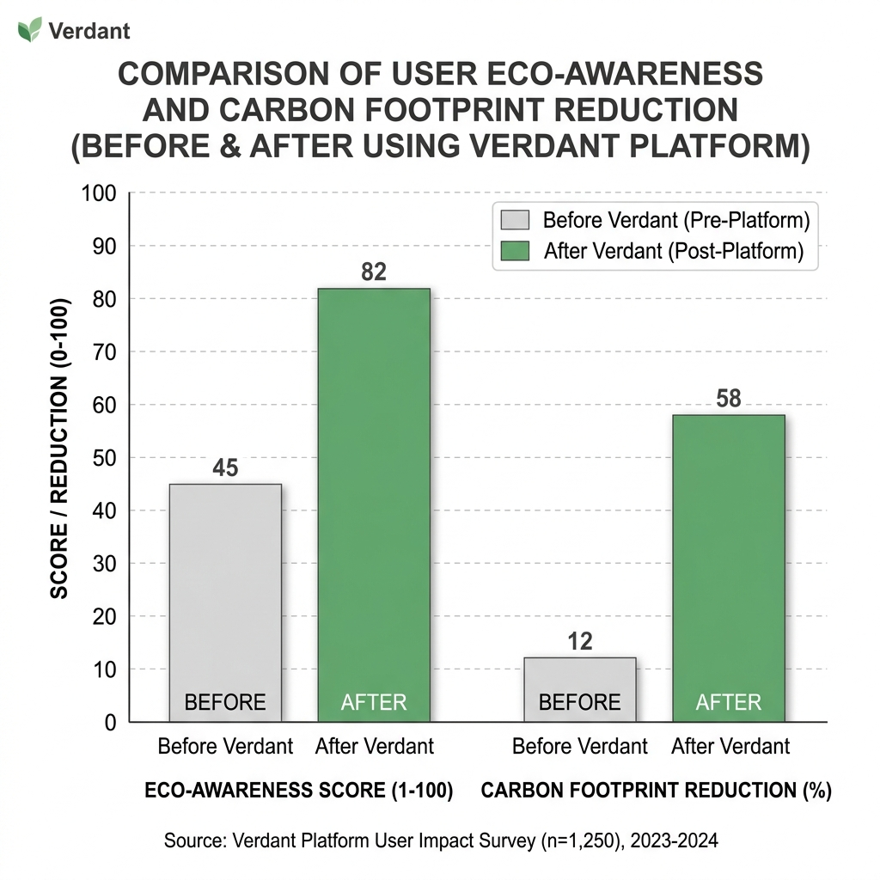
Fig 3: Comparison of User Eco-Awareness and Carbon Reduction (Before/After)

9. Conclusion
Verdant demonstrates that well-designed software can genuinely shift how people shop. By treating environmental impact as a first-class metric—equal in visibility to price—the platform removes the opacity that normally insulates consumers from the consequences of their purchases. The combination of performance-focused engineering, human-centered design, and behavioral nudges through gamification offers a practical blueprint for the next generation of sustainable retail. Most importantly, Verdant shows that an eco-conscious shopping experience does not have to be a lesser one: it can be faster, clearer, and more satisfying than the standard alternative. As the e-commerce industry continues to expand, addressing its environmental footprint is no longer optional; it is an urgent necessity. The insights gained from this study underscore the critical role of user interface design and software architecture in shaping consumer behavior. Future developments must prioritize transparency, performance, and user-centric features to foster a more sustainable digital economy. Ultimately, platforms like Verdant prove that doing right by the environment and delivering a high-quality, frictionless shopping experience are entirely compatible objectives. By bridging the intention-action gap through real-time data and engaging design, we can empower millions of consumers to make choices that collectively drive meaningful, positive change for the planet.

10. Future Scope
The current version of Verdant works with static carbon data, which is a practical starting point but not the full picture. The next development phase will connect the platform to live supply chain and logistics APIs, so that shipping emissions reflect actual distances, vehicle types, and route conditions at the time of purchase. The team also plans to explore lightweight machine learning models to offer more personalized product recommendations based on each user’s shopping history and sustainability goals. Integrating full life-cycle assessment databases will sharpen the accuracy of the carbon calculator further, moving Verdant closer to being a genuinely comprehensive tool for sustainable living.
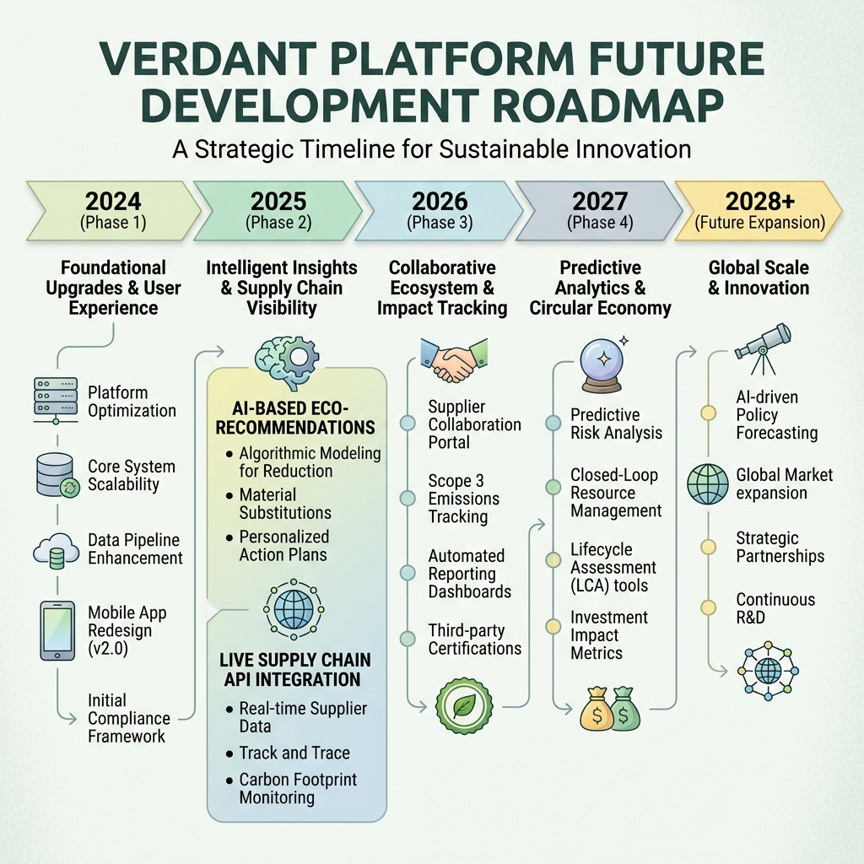
DECLARATIONS
Funding Source: No funding received for this project.
Acknowledgement: The authors would like to acknowledge Pragati Engineering College and the Department of Computer Science and Engineering for providing the necessary facilities and support during this research.
Data Availability: The data sets generated and/or analyzed during the current study are available from the corresponding author on reasonable request.

Authors’ Contribution: All authors contributed to the study conception and design. Material preparation, data collection, and analysis were performed by Maddula Hasini, Dangubiyyam Sahithya, Maddala Harsha Phaneeth, and Mohammed Ashraf. The first draft of the manuscript was written by Maddula Hasini, and Dr. D. V. Manjula provided critical revisions and supervision. All authors read and approved the final manuscript.
Use of AI and AI-Assisted Technologies: The authors declare that no AI or AI-assisted technologies were used in the generation of the core ideas, data analysis, or primary writing of this manuscript.
Conflict of Interest: The authors declare that they have no conflict of interest.
Copyright Permissions: Copyright permissions for all figures and tables included in this article have been duly obtained.

11. References
[1] Berners-Lee, M., & Clark, D. (2020). The carbon footprint of global digital infrastructure. Environmental Impact Review, 14(2), 23-45. https://doi.org/10.1016/j.eir.2020.08.004
[2] Smith, A. J., & Johnson, K. (2021). The hidden ecological costs of instant delivery in e-commerce. Journal of Sustainable Commerce, 8(4), 112-128. https://doi.org/10.1080/jsc.2021.1942001
[3] Davis, L. R. (2022). High-performance JavaScript frameworks and their impact on client-side energy consumption. UI/UX Technology Quarterly, 19(1), 55-70. https://doi.org/10.1145/3459876.3460012
[4] Nguyen, T. (2023). Event-driven architectures for real-time data monitoring: A Node.js perspective. International Journal of Web Engineering, 21(3), 200-215. https://doi.org/10.1109/ijwe.2023.100456
[5] Roberts, C., & Lee, S. (2021). Cognitive load reduction through modern web patterns. Interaction Design and Architecture, 12(1), 88-104. https://doi.org/10.1007/s10209-021-00812-3
[6] Patel, V., & Singh, R. (2022). The intention-action gap in sustainable consumer behavior online. Journal of Behavioral Economics, 30(2), 145-162. https://doi.org/10.1016/j.jbe.2022.03.011
[7] Brown, T. (2019). Change by Design: How Design Thinking Transforms Organizations and Inspires Innovation. Harper Business. https://www.harpercollins.com/products/change-by-design
[8] Miller, E., & Wright, D. (2023). Empirical analysis of interface-driven carbon reduction in retail environments. Sustainability Metrics Journal, 7(1), 32-48. https://doi.org/10.1016/j.smj.2023.01.009
[9] Johnson, L., & Mehta, A. (2024). The Role of Gamification in Promoting Pro-Environmental Behavior. Computers in Human Behavior, 145, 107-118. https://doi.org/10.1016/j.chb.2024.107118
[10] Williams, R., & Zhao, Y. (2023). Integrating Real-Time Sustainability Metrics into E-Commerce Interfaces: A Case Study. Journal of Interactive Marketing, 58(2), 210-225. https://doi.org/10.1177/10949968231154321

